ARYAMAN MISHRA

19BCE1027 LAB 2

BUSINESS USE MODEL

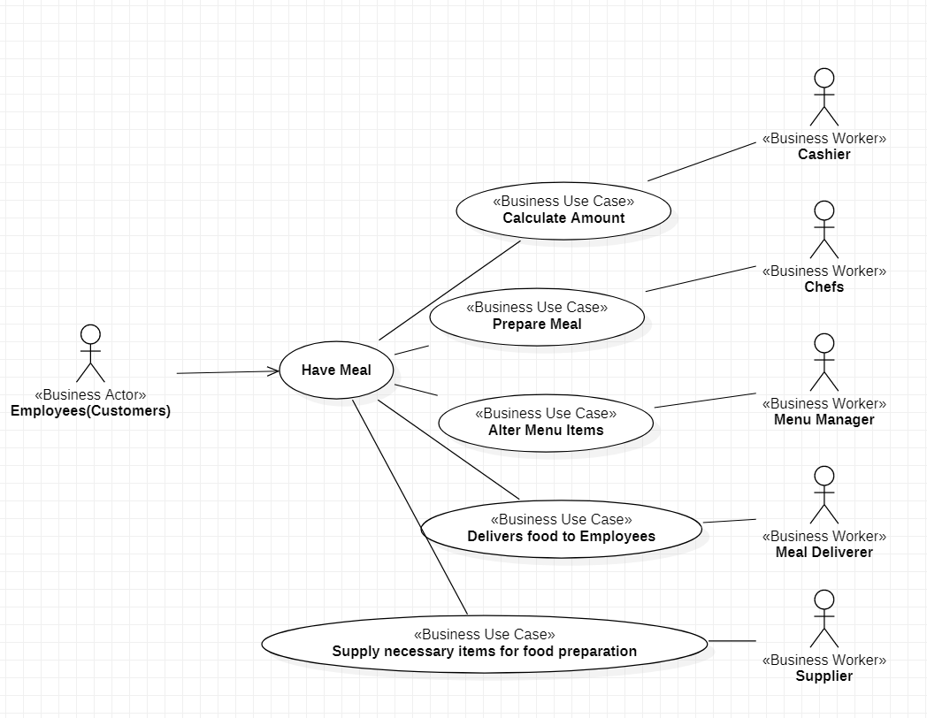

BUSINESS ACTOR-EMPLOYEES(CUSTOMERS)

BUSINESS WORKERS-MENU MANAGER,SUPPLIER,CHEFS,CASHIER,MEAL DELIVERER

BUSINESS USE CASES-AMOUNT CALCULATION,FOOD DELIVERY,PREPARATION,SUPPLYING OF FOOD MATERIALS,ALTERING OF MENU ITEMS

BUSINESS ENTITIES-ACTORS,WORKERS,USE CASES